Amazon Customer Service chatbot
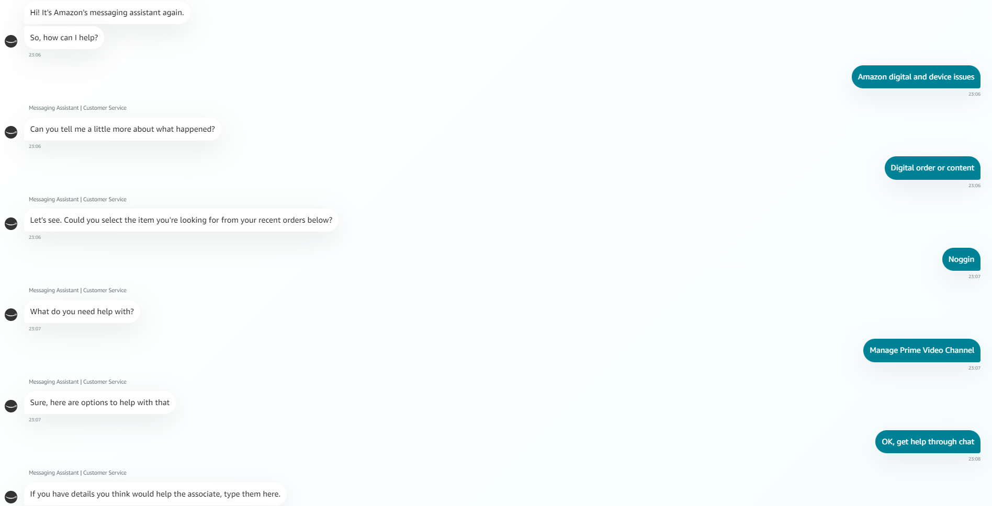
It’s a pre-programmed prompts and clicks chatbot, aimed to screen the FAQ solvable problems to reduce human assistant’s workload.
The answer time is almost instant, but when you have an actual problem, they are seldom helpful.

Geico Virtual Assistant
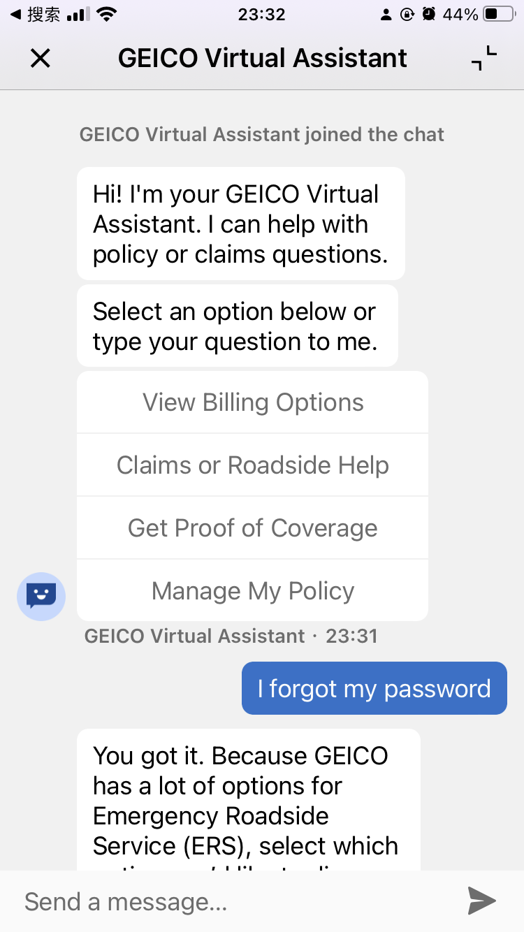
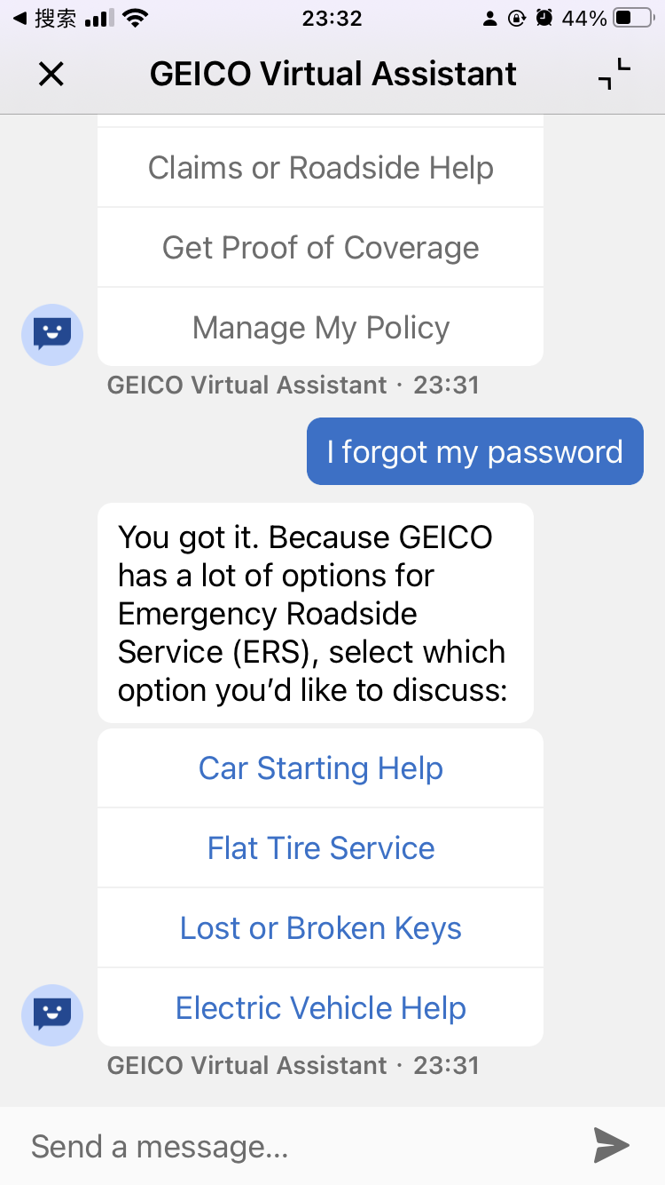
I tried to log in from web browser, but I forgot my password, so I had to turn to the mobile app. And within 1 minute, the Geico Virtual Assistant’s intelligence managed to astonish me! I said I forgot my password, he comforted me with kind words and offered me ERS, Emergency Roadside Service! How marvelous!
Pre-programed, click prompted, instant reply, alarmingly low intelligence.

Chase Digital Assistant
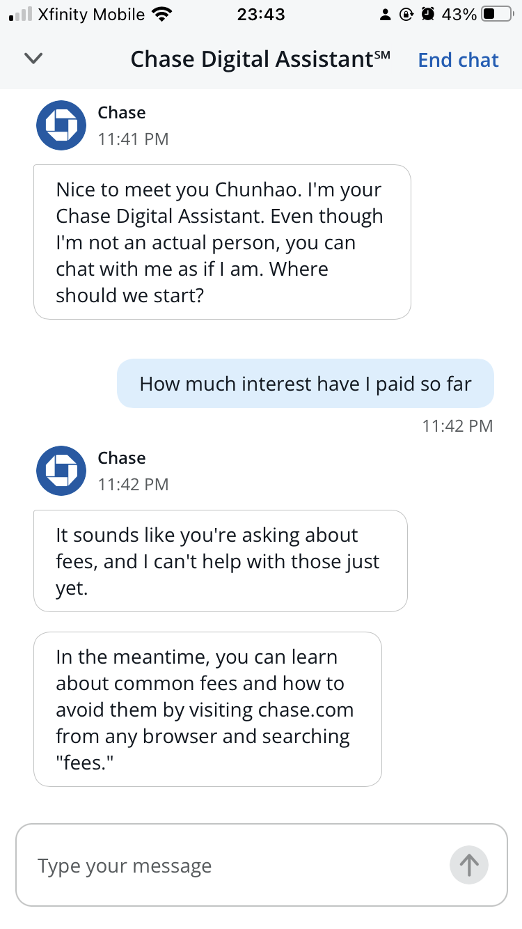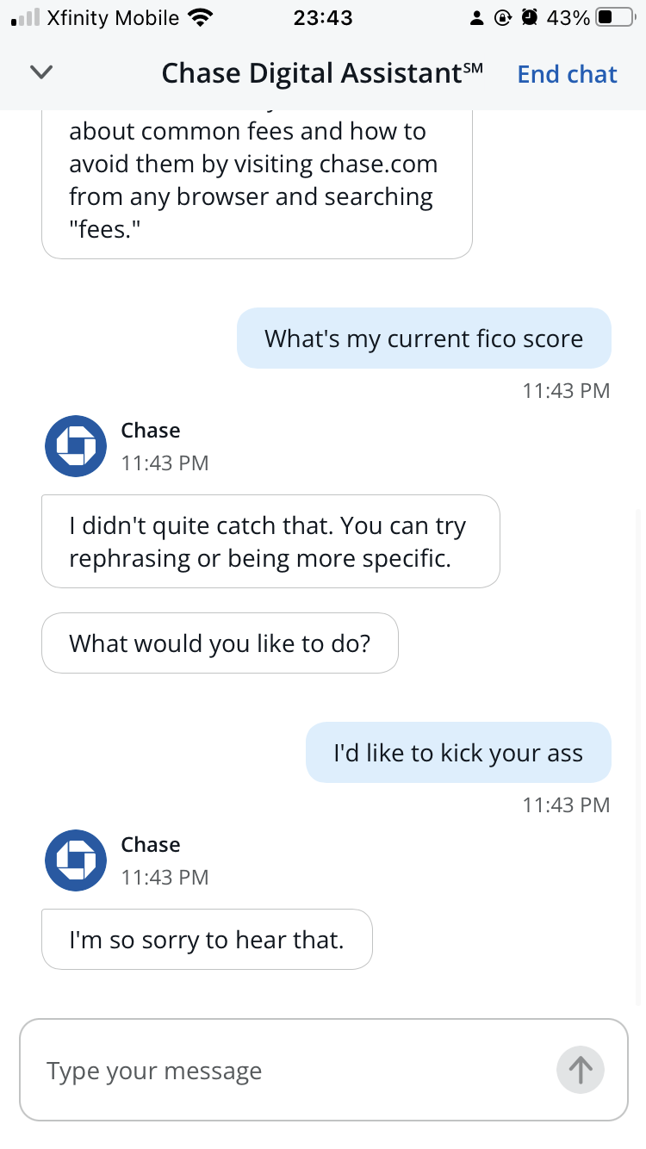
Reply was instant, the scope of pre-programmed solutions was narrow. As a bank digital assistant, can’t even answer simple questions as paid interests, and FICO score, shame.

Summary
Looks like none of the companies I investigated has utilized AI based chatbot. Since there’s no or almost no NLP was built in them, they cannot respond to any random inputs from users. In most cases, if they can’t find a matching scenario from the template, they’d just reply something like “Sorry I don’t understand what you just said, could you please rephrase?”

Reflection
This homework made me realize that although virtual assistant has been in business for decades, AI based chatbots are still not occupying much of the market. It indicates a very promising future ahead of us, many more are yet to be convinced into deploying it.

